Gender Recognition By Voice

*Nandigam Subash Chandra Sameer,*

*AI Club*

*Vijayawada, India.*

[sameernandigam@gmail.com](mailto:sameernandigam@gmail.com)*.*

**ABSTRACT:**This document is about to describe the project “**Gender Recognition By Voice**”. A small dataset is used for training and testing this model. This database was created to identify a voice as male or female based upon acoustic properties of the voice and speech. The dataset consists of 3,186 recorded voice samples collected from male and female speakers. The voice samples are pre-processed by acoustic analysis using the seewave. This is done with an analyzed frequency range of 0hz – 280hz (human vocal range) . In this project I have used Python code to test, train and split the Dataset. I have used “**sklearn”,”pandas”** , these modules and **“LogisticRegression”,”KNeighbourClassifier”,”RandomForestClassifier”** , these algorithms in the model. This model predicts the Gender of a person by their voice. This model has achieved an accuracy of 98% during validation with good precision value.

## INTRODUCTION:

There are so many genders in this world. But mainly we consider two genders in our daily life. They are “**Male**” and “**Female**”. While listening to the voices it is very easy for us to recognize whether the person is male or female. But now we are using computers to recognize them. Now-a-days , we are using machine learning to make our work easier . It plays a key role in reducing the time and energy being used. So, this project is made using Machine Learning . These days we are getting calls from scammers using deepfake of voices and faces. By using this model, we can detect the gender of the scammers when they call using AI deep fake voice by the help of frequency and pitch of the voice.

This model helps in preventing scams from scammers . Females often have a softer voice while men have a harsher voice . In general women speak at a higher pitch and men at a lower pitch. According to some surveys, women's speech pitch is about 196Hz-224 Hz and men's speech pitch is about 107Hz-132 Hz.

This model also helps in many applications like biometric, human – computer interaction, forensic analysis,Market research,Healthcare applications,demographic statistics, retail shops, surveillance etc.



## MATERIALS AND METHODS:

This database was created to identify a voice as male or female, based upon acoustic properties of the voice and speech. The dataset consists of 3,168 recorded voice samples, collected from male and female speakers.I have collected the dataset from kaggle and the source can be found here [1] .

Dataset is a CSV file which contains 21 features and one label column which has the following categories. This label has two classifications “**Male**” and “**Female**”. The developed model classifies the sample into two labels. This model mainly depends on mean frequency which is measured in “**kHz**” units.  
 I got logistic regression accuracy as 97% which is a very good precision value. In random forest classification I got 98% accuracy which is the highest of all. So I have used the Random Forest Model.

**LogisticRegression:**Logistic regression is a widely used machine learning algorithm for binary classification tasks, where the goal is to predict the probability that an instance belongs to a given class or not. It’s a statistical algorithm that analyzes the relationship between two data factors and produces a probability value between 0 and 1. The algorithm is referred to as regression because it’s an extension of linear regression, but it’s mainly used for classification problems.

**RandomForest:**Random forests or random decision forests is an ensemble learning method for classification, regression and other tasks that operates by constructing a multitude of decision trees at training time.

## 

## 

## RESULTS:

You can check confusion matrix of the trained model:

**CONFUSION MATRIX:** The confusion matrix is a table used in machine learning to visualize the performance of a classification algorithm. It is a square table with two rows and two columns, where each cell represents the number of instances that have been classified into a particular class. The rows represent the actual classes, and the columns represent the predicted classes.

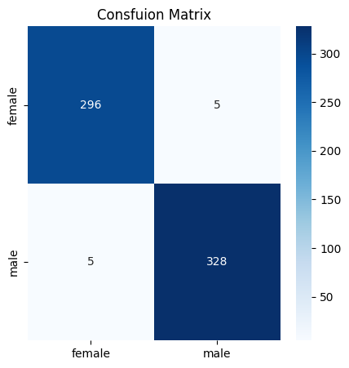

In the above figure 2 category modules struggle to distinguish between “**Male**” and “**Female**”. Here the distinction with “**Male**” is well achieved. **RandomForest** classification is used to get the graph as it shows the best accuracy.

You can check the accuracy of my project:

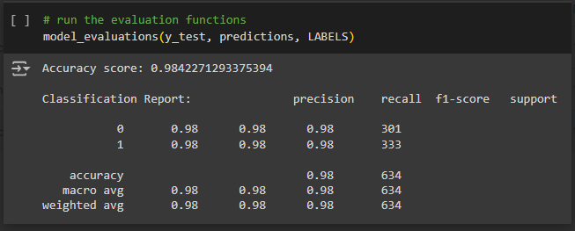

## 

## 

## 

## 

## 

## 

## FUTURE WORK :

There are approximately 74 genders in the world including Male and Female. For now this model works only for 2 genders “**Male**” and ”**Female**”. In the future we are going to add some more genders.RESOURCES :

1. To know about voice dataset , refer   
   <https://www.kaggle.com/datasets/primaryobjects/voicegender>
2. To see complete details of my project , refer   
   <https://github.com/sameer5500/Gender_Recognization_By_Voice>